
ICP-4721: Natural Language Processing
Laboratory 3: More on Named Entity Recognition; Text Classification and Sentiment Analysis
Bill Teahan

Exercises
For this module’s laboratory sessions, you will need to produce a report that includes the answers to each of the lab exercises and then submit the report to Blackboard. You will have two weeks to complete the report. Marks (out of 100) are shown at the top of each exercise. Try to complete the exercises within the two lab sessions otherwise you will need to complete the exercises in your own time. There will be four labs for this module, so as the lab weighting is 50%, this means that each lab report is worth 12.5%. Feedback on the previous week’s lab will be provided the following week so have your lab report and programs ready for checking.

Please do not include the questions in the lab report – just the answers – as this will affect the similarity index for your report for the TurnItIn plagiarism software.

Academic Integrity
You will be personally asked questions for every lab report you submit. These questions will be individualised based on the answers you have provided in the report. If you fail to answer the questions satisfactorily, this may result in a reduction in your mark, and/or may result in you being referred to a school panel if there are any AI (Academic Integrity) concerns. Ultimately, this may result in you being assigned a 0 mark for the assessment. To avoid this, please make sure the work you submit is 100% your own! Do not use Generative AI to generate answers to any of the questions below.

Submission Deadline
All lab work will be due at midnight on Tuesday of the week when it is due (i.e. the night before the next lab session).

Documentation
Official Python website – Python.org:
http://www.python.org/
For further information and documentation, you can also try the Python Wiki:
http://wiki.python.org/moin/
O’Reilly Media – “Learning Python” :
http://oreilly.com/catalog/9780596513986/

Named Entity Recognition in spaCy
spaCy is another NLP Python library available from https://spacy.io/. It is claimed to be “industrial strength” (although such claims are now debatable because of the recent release of Generative AI methods using Large Language Models). Let’s find out how good it really is.
Go to this website, and in particular familiarise yourself with the API (https://spacy.io/api).
The following short program (which can be found in the file spacy_test in the Lab03 folder in Blackboard) will perform basic named entity recognition on a short amount of text:
# pip install -U spacy
# python -m spacy download en_core_web_sm
import spacy

# Load English tokenizer, tagger, parser and NER
nlp = spacy.load("en_core_web_sm")

# Process whole documents
text = ("When Sebastian Thrun started working on self-driving cars at "
"Google in 2007, few people outside of the company took him "
"seriously. “I can tell you very senior CEOs of major American "
"car companies would shake my hand and turn away because I wasn’t "
"worth talking to,” said Thrun, in an interview with Recode earlier "
"this week.")
doc = nlp(text)

# Analyze syntax
print("Noun phrases:", [chunk.text for chunk in doc.noun_chunks])
print("Verbs:", [token.lemma_ for token in doc if token.pos_ == "VERB"])

# Find named entities, phrases and concepts
for entity in doc.ents:
print(entity.text, entity.label_)
Note that you will need to install the SpaCy libraries and datasets using the two commented lines in the above program to get this to work.

Exercise 3.1 – NE chunking in SpaCy and NLTK (35 Marks)
Test out the NE chunking code above on at least 4 sample paragraphs (including the one in the program above). Then use the NLTK to do the same thing. Compare and contrast the effectiveness of the two Python libraries at identifying the named entities in your sample paragraphs. Hint: Use some metric or metrics to quantify how effective the two libraries are (see below).

Text Classification and Language Identification
An important Natural Language Processing task is text classification – assigning a specific label to a text message. The label might be the name of the author (for authorship ascription such as whether the text message was written by Shakespeare, for example, or by one of his contemporaries such as Edward de Vere or Francis Bacon). Or it might be the topic (such as about playing video games, about how to fix a car, or about the Six Nations rugby match that was played on the weekend, say), or it might be the genre (such as news, sport, science fiction or romance, say), the sentiment (such as whether the movie is a good movie to watch, say), or the language (whether the text is in English, French, Welsh or Swahili, say). If your program could identify that someone has typed in a message in a different language (such as Welsh or Spanish), it could simply reply “Sorry, I don’t understand Spanish. Please type your message or question in English!” Or it could try to understand the text (if it was written in Welsh, for example).
Writing code for language identification is very easy. We can simply create a small list of common words in each language, and then if we spot them in the text sequence we are trying to identify, we can set the label for the text to the associated language. For example, in English, the list might be:
[ the, a, and, of, be, that, have, it, for, not ]
For French, a list of common words might be:
[ le, la, de, ne, et, un, pas, vous, etre, les, en ]
We can count how many common words occur in the text from each of the above lists, and then choose the language associated with the list that has the greatest number of common words.

Exercise 3.2 – Tower of Babel (10 Marks)
Write some Python code that will identify the language of a text string using the above method. Make sure that your code is able to identify at least three languages.
Post your code, and sample output along with a description into the report.
As is always the case when building a Natural Language Processing system, once you have built the system, you need to have some way of evaluating how well the system works. For text classification tasks, one way of measuring the effectiveness of your program is to calculate the accuracy. This measures the percentage of the test set that the classifier correctly labelled. For example, if you had 20 sentences in your test set that are written in different languages, and it correctly identified 17 of them, then the accuracy would be 17/20 or 85%.

Exercise 3.3 – Evaluating Your Tower of Babel (10 Marks)
Create a test set of 10 sentences that contain sample sentences from the languages you used for Exercise 3.2.
In your report, include your test set of sentences and paste the program output from your language identification program you devised for Exercise 3.2 when these test sentences are used as input. Work out the accuracy of your system and include it in your report.

To read more about text classification and how it can be done using the NLTK, go to: http://www.nltk.org/book/ch06.html.
To read more about the Oxfordian theory of Shakespeare authorship, see:
http://en.wikipedia.org/wiki/Oxfordian_theory_of_Shakespeare_authorship

The remaining part of this lab is based on the following web page:
https://www.datacamp.com/tutorial/text-analytics-beginners-nltk
Sentiment Analysis
Sentiment analysis is a technique used to determine the emotional tone or sentiment expressed in a text. It involves analysing the words and phrases used in the text to identify the underlying sentiment, whether it is positive, negative, or neutral.
Sentiment analysis has a wide range of applications, including social media monitoring, customer feedback analysis, and market research.
One of the main challenges in sentiment analysis is the inherent complexity of human language. Text data often contains sarcasm, irony, and other forms of figurative language that can be difficult to interpret using traditional methods.
However, recent advances in natural language processing (NLP) and machine learning have made it possible to perform sentiment analysis on large volumes of text data with a high degree of accuracy.
Three Methodologies for Sentiment Analysis
There are several ways to perform sentiment analysis on text data, with varying degrees of complexity and accuracy. The most common methods include a lexicon-based approach, a machine learning (ML) based approach, and a pre-trained transformer-based deep learning approach. Let’s look at each in more detail:
Lexicon-based analysis
This type of analysis, such as the NLTK Vader sentiment analyzer, involves using a set of predefined rules and heuristics to determine the sentiment of a piece of text. These rules are typically based on lexical and syntactic features of the text, such as the presence of positive or negative words and phrases.
While lexicon-based analysis can be relatively simple to implement and interpret, it may not be as accurate as ML-based or transformed-based approaches, especially when dealing with complex or ambiguous text data.
Machine learning (ML)
This approach involves training a model to identify the sentiment of a piece of text based on a set of labeled training data. These models can be trained using a wide range of ML algorithms, including decision trees, support vector machines (SVMs), and neural networks.
ML-based approaches can be more accurate than rule-based analysis, especially when dealing with complex text data, but they require a larger amount of labeled training data and may be more computationally expensive.
Pre-trained transformer-based deep learning
A deep learning-based approach, as seen with BERT and GPT-4, involve using pre-trained models trained on massive amounts of text data. These models use complex neural networks to encode the context and meaning of the text, allowing them to achieve state-of-the-art accuracy on a wide range of NLP tasks, including sentiment analysis. However, these models require significant computational resources and may not be practical for all use cases.
- Lexicon-based analysis is a straightforward approach to sentiment analysis, but it may not be as accurate as more complex methods.
- Machine learning-based approaches can be more accurate, but they require labeled training data and may be more computationally expensive.
- Pre-trained transformer-based deep learning approaches can achieve state-of-the-art accuracy but require significant computational resources and may not be practical for all use cases.
The choice of approach will depend on the specific needs and constraints of the project at hand.
Preprocessing Text
Text preprocessing is a crucial step in performing sentiment analysis, as it helps to clean and normalize the text data, making it easier to analyze. The preprocessing step involves a series of techniques that help transform raw text data into a form you can use for analysis. Some common text preprocessing techniques include tokenization, stop word removal, stemming, and lemmatization:
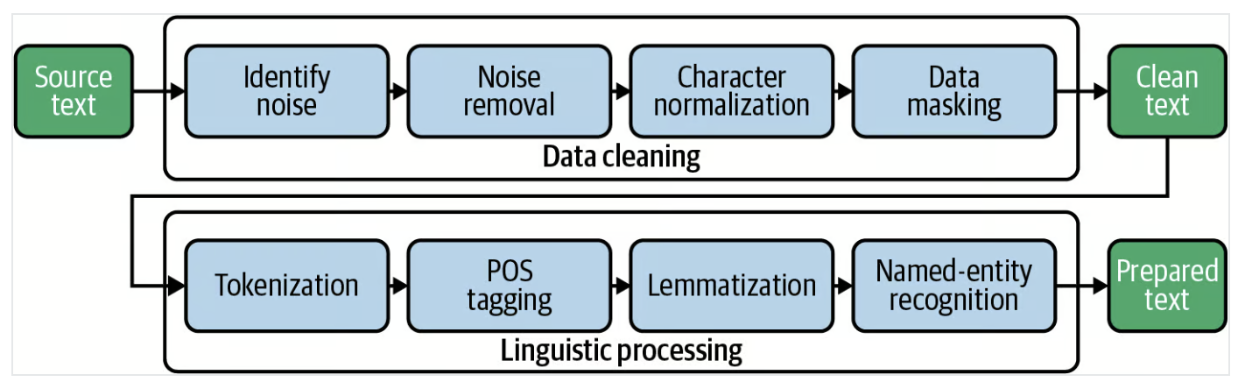
Tokenization
Tokenization is a text preprocessing step in sentiment analysis that involves breaking down the text into individual words or tokens. This is an essential step in analyzing text data as it helps to separate individual words from the raw text, making it easier to analyze and understand. Tokenization is typically performed using NLTK's built-in word_tokenize function, which can split the text into individual words and punctuation marks.
Stop words
Stop word removal is a crucial text preprocessing step in sentiment analysis that involves removing common and irrelevant words that are unlikely to convey much sentiment. Stop words are words that are very common in a language and do not carry much meaning, such as "and," "the," "of," and "it." These words can cause noise and skew the analysis if they are not removed.
By removing stop words, the remaining words in the text are more likely to indicate the sentiment being expressed. This can help to improve the accuracy of the sentiment analysis. NLTK provides a built-in list of stop words for several languages, which can be used to filter out these words from the text data.

Stemming and Lemmatization
Stemming and lemmatization are techniques used to reduce words to their root forms. Stemming involves removing the suffixes from words, such as "ing" or "ed," to reduce them to their base form. For example, the word "jumping" would be stemmed to "jump."
Lemmatization, however, involves reducing words to their base form based on their part of speech. For example, the word "jumped" would be lemmatized to "jump," but the word "jumping" would be lemmatized to "jumping" since it is a present participle.
To learn more about stemming and lemmatization, check out the following Stemming and Lemmatization in Python tutorial.
Bag of Words (BoW) Model
The bag of words model is a technique used in natural language processing (NLP) to represent text data as a set of numerical features. In this model, each document or piece of text is represented as a "bag" of words, with each word in the text represented by a separate feature or dimension in the resulting vector. The value of each feature is determined by the number of times the corresponding word appears in the text.
The bag of words model is useful in NLP because it allows us to analyze text data using machine learning algorithms, which typically require numerical input. By representing text data as numerical features, we can train machine learning models to classify text or analyze sentiments.
The example in the next section (whose code can be found the the file process_reviews.py in the Lab03 folder in Blackboard, and also in the Notebook link below) uses the NLTK Vader model for sentiment analysis on the Amazon customer dataset. In this particular example, we do not need to perform this step because the NLTK Vader API accepts text as an input instead of numeric vectors, but if you were building a supervised machine learning model to predict sentiment (assuming you have labelled data), you would have to transform the processed text into a bag of words model before training the machine learning model.
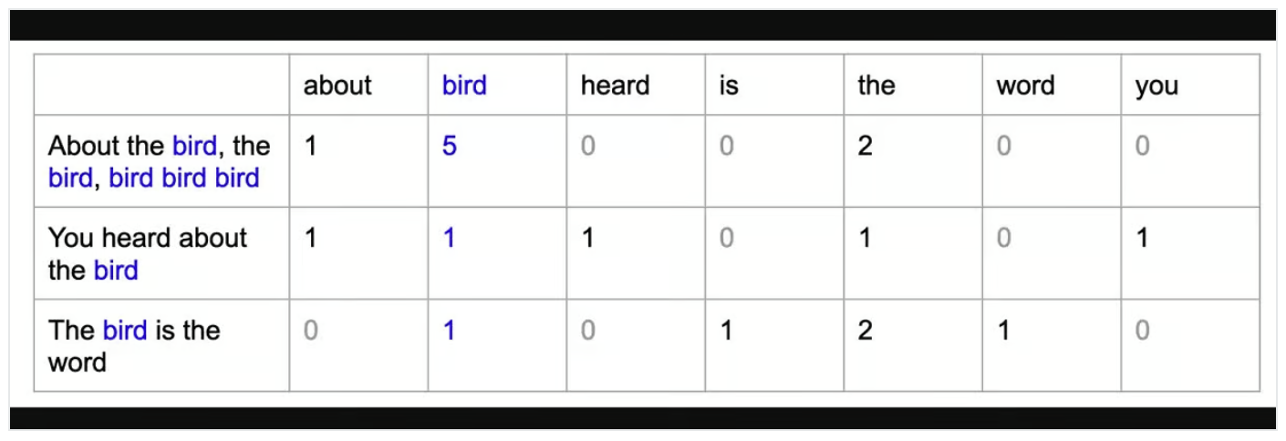
End-to-end Sentiment Analysis Example in Python
To perform sentiment analysis using the NLTK in Python, the text data must first be preprocessed using techniques such as tokenization, stop word removal, and stemming or lemmatization. Once the text has been preprocessed, we will then pass it to the Vader sentiment analyzer for analyzing the sentiment of the text (positive or negative).
Step 1 - Import libraries and load dataset
First, we’ll import the necessary libraries for text analysis and sentiment analysis, such as pandas for data handling, nltk for natural language processing, and SentimentIntensityAnalyzer for sentiment analysis.
Make sure you have already downloaded all of the NLTK corpus (a collection of linguistic data) using nltk.download().
Once the environment is set up, we will load a dataset of Amazon reviews using pd.read_csv(). This will create a DataFrame object in Python that we can use to analyze the data. We'll display the contents of the DataFrame using df.
# import libraries
import pandas as pd
import nltk

# need to download nltk corpus first (one time only)
#
#nltk.download('all')

from nltk.sentiment.vader import SentimentIntensityAnalyzer
from nltk.corpus import stopwords
from nltk.tokenize import word_tokenize
from nltk.stem import WordNetLemmatizer

# Load the amazon review dataset (using sample in Blackboard)
df = pd.read_csv ('amazon.csv')
df

This will produce the following output:

reviewText Positive
0 This is a one of the best apps acording to a b... 1
1 This is a pretty good version of the game for ... 1
2 this is a really cool game. there are a bunch ... 1
3 This is a silly game and can be frustrating, b... 1
4 This is a terrific game on any pad. Hrs of fun... 1
.. ... ...
993 This app is powerful and easy to use. I use it... 1
994 Great, life-changing app. Love its customizab... 1
995 Bleh 0
996 The concept of this alarm clock is very very s... 1
997 So many people commenting on the permissions b... 0

[998 rows x 2 columns]

Step 2 - Preprocess text
Let’s create a function preprocess_text in which we first tokenize the documents using the word_tokenize function from the NLTK, then we remove step words using the stepwords module from NLTK and finally, we lemmatize the filtered_tokens using the WordNetLemmatizer from the NLTK.

# create preprocess_text function
def preprocess_text(text):
# Tokenize the text
tokens = word_tokenize(text.lower())

# Remove stop words
filtered_tokens = [token for token in tokens if token not in stopwords.words('english')]

# Lemmatize the tokens
lemmatizer = WordNetLemmatizer()
lemmatized_tokens = [lemmatizer.lemmatize(token) for token in filtered_tokens]

# Join the tokens back into a string
processed_text = ' '.join(lemmatized_tokens)

return processed_text

# apply the function df
df['reviewText'] = df['reviewText'].apply(preprocess_text)
df

This produces the following output:

reviewText Positive
0 one best apps acording bunch people agree bomb... 1
1 pretty good version game free . lot different ... 1
2 really cool game . bunch level find golden egg... 1
3 silly game frustrating , lot fun definitely re... 1
4 terrific game pad . hr fun . grandkids love . ... 1
.. ... ...
993 app powerful easy use . use primary alarm cloc... 1
994 great , life-changing app . love customizabili... 1
995 bleh 0
996 concept alarm clock simple . also effective . ... 1
997 many people commenting permission anyone even ... 0

[998 rows x 2 columns]

Notice the changes in the "review text" column as a result of the function preprocess_text that we applied in the above step.

Step 3 - NLTK Sentiment Analyzer
First, we’ll initialize a Sentiment Intensity Analyzer object from the nltk.sentiment.vader library.

Next, we’ll define a function called get_sentiment that takes a text string as its input. The function calls the polarity_scores method of the analyzer object to obtain a dictionary of sentiment scores for the text, which includes a score for positive, negative, and neutral sentiment.

The function will then check whether the positive score is greater than 0 and returns a sentiment score of 1 if it is, and a 0 otherwise. This means that any text with a positive score will be classified as having a positive sentiment, and any text with a non-positive score will be classified as having a negative sentiment.

Finally, we’ll apply the get_sentiment function to the reviewText column of the df DataFrame using the apply method. This creates a new column called sentiment in the DataFrame, which stores the sentiment score for each review. We then display the updated DataFrame using df:

nltk.download('vader_lexicon')

# initialize NLTK sentiment analyzer
analyzer = SentimentIntensityAnalyzer()

# create get_sentiment function
def get_sentiment(text):
scores = analyzer.polarity_scores(text)
sentiment = 1 if scores['pos'] > 0 else 0
return sentiment

# apply get_sentiment function
df['sentiment'] = df['reviewText'].apply(get_sentiment)
print (df)

This produces the following output:

reviewText Positive sentiment
0 one best apps acording bunch people agree bomb... 1 1
1 pretty good version game free . lot different ... 1 1
2 really cool game . bunch level find golden egg... 1 1
3 silly game frustrating , lot fun definitely re... 1 1
4 terrific game pad . hr fun . grandkids love . ... 1 1
.. ... ... ...
993 app powerful easy use . use primary alarm cloc... 1 1
994 great , life-changing app . love customizabili... 1 1
995 bleh 0 0
996 concept alarm clock simple . also effective . ... 1 1
997 many people commenting permission anyone even ... 0 0

[998 rows x 3 columns]

The NLTK sentiment analyzer returns a score between -1 and +1. We have used a cut-off threshold of 0 in the get_sentiment function above. Anything above 0 is classified as 1 (meaning positive). Since we have actual labels, we can evaluate the performance of this method by building a confusion matrix.

from sklearn.metrics import confusion_matrix
print(confusion_matrix(df['Positive'], df['sentiment']))

This produces the following output:

[998 rows x 3 columns]
[[ 24 91]
[ 24 859]]

Exercise 3.4 – Confusion Matrix (10 Marks)
In your report, explain in your own words what a confusion matrix is, and also specifically explain the output that was produced above and what the numbers mean.

We can also check the classification report:

from sklearn.metrics import classification_report
print(classification_report(df['Positive'], df['sentiment']))

This produces the following output:

precision recall f1-score support

0 0.50 0.21 0.29 115
1 0.90 0.97 0.94 883

accuracy 0.88 998
macro avg 0.70 0.59 0.62 998
weighted avg 0.86 0.88 0.86 998

As you can see, the overall accuracy of this rule-based sentiment analysis model is 88%. Since this is labelled data, you can also try to build an ML model (using one of the ML models in the sklearn library) to evaluate if an ML-based approach will result in better accuracy.

Check out the full notebook on the Datacamp workspace.

Exercise 3.5 – More Evaluation Metrics (15 Marks)
The above output produced results for more than just the accuracy metric – it included results for precision, recall and f1-score.
In your report, explain in your own words what each of these metrics mean and define them mathematically based on the confusion matrix output.

Exercise 3.6 – Your Own Sentiment Analysis Results (20 Marks)
The above output produced results for a small sample from the Amazon reviews dataset. What happens when you try it out on a different sample taken from the much larger original dataset?
Download the original dataset from:
https://raw.githubusercontent.com/pycaret/pycaret/master/datasets/amazon.csv
Create two 1000 line random samples from this dataset. Using the above code, generate confusion matrix output and the classification report for each sample and include in your report. Compare the results from your two samples with the results for the third sample that is included above.
Note: Your two new samples need to be randomized so that they do not match any other samples that might be submitted by other students. Therefore, the output results you produce will also be different to any other submission. If they match any other submission, you will receive zero marks due to plagiarism.

Conclusion
NLTK is a powerful and flexible library for performing sentiment analysis and other natural language processing tasks in Python. By using NLTK, we can preprocess text data, convert it into a bag of words model, and perform sentiment analysis using Vader's sentiment analyzer.

We have explored the basics of NLTK sentiment analysis, including preprocessing text data, creating a bag of words model, and performing sentiment analysis using NLTK Vader. We have also discussed the advantages and limitations of NLTK sentiment analysis, and provided suggestions for further reading and exploration.

Overall, NLTK is a powerful and widely used tool for performing sentiment analysis and other natural language processing tasks in Python. By mastering the techniques and tools presented in this lab you can gain valuable insights into the sentiment of text data and use these insights to make data-driven decisions in a wide range of applications.
If you want to learn how to apply NLP to real-world data, including TED talks, articles, and movie reviews, using Python libraries and frameworks, including NLTK, scikit-learn, spaCy, and SpeechRecognition, check out the resources below:
- Introduction to Natural Language Processing in Python
- Natural Language Processing in Python

It provides a strong foundation for processing and analysing text data using Python. Whether you're new to NLP or looking to expand your skills, this course will equip you with the tools and knowledge to convert unstructured data into valuable insights.

